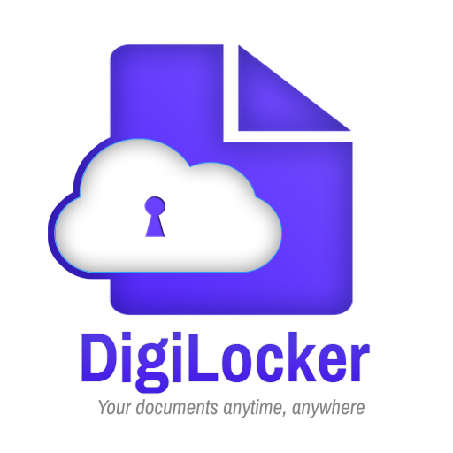

**Digilocker integration process -doit&c**

Represented By:

Department of information technology & communication

JAIPUR

July 21, 2022

**Table of Contents:**

1. Introduction: 1

2. How to Integrate Digi Locker DOIT&C Platform: 2

2.1. Redirection of User on Digi locker website: 2

2.2. Get Document from Digi Locker: 2

3. Process Description: 3

# Introduction:

Digital Locker is a key initiative under Digital India program. It aims at eliminating the use of physical documents and enables sharing of verified electronic documents across agencies. Digital Locker provides a dedicated personal storage space of 1GB in the cloud to citizens. It will enable various organizations registered on Digital Locker to push certificates of citizens directly in their Digital Locker in electronic format. Citizens can also upload and securely store the scanned copies of legacy documents in Digital Locker. These legacy documents can be electronically signed using eSign facility. A citizen can share these electronic certificates online with various departments and agencies registered on Digital Locker while applying for the services provided by them. Thus, Digital Locker brings the citizens, issuers and requestors on one platform.

This document provides technical details of Digi Locker integration with applications of trusted partners. This document assumes that the reader is aware of Digital Locker application functionality.

# How to Integrate Digi Locker DOIT&C Platform:

## Token Generate Authentication:

## URL:

https://api.sewadwaar.rajasthan.gov.in/app/live/Aadhaar/prod/DOCUMENTVERIFICATIONENGINEWEBAPI/token?client_id=<client id>

##### **Request Parameters:**

UserName : Enter your SSO ID

Password : WRAPPERAPIUSER Grant_Type: password

##### **Response json:**

##### 

##### **Successful Response**:

{

"access_token": "q2W6Gc6qSw5NY2WKOQ- 8seWnEetShLzkMIW1X1zyveXhts8tUHQdNR_tElP57Ollwi37BRqXtatewxxIF0HyeBMq Wvdwwe2dSyarhXLz5ejqHLG3JH8pWZfiXWwT9Bi5xfL6v097KFbO5bXH0myxW7H29Fl Z2S4qsuRTfLemvDNipdlLV2ATcRFiViqllUt1tTQJ0jqVT- pJ6RjeFGX3YQd_Da_Vnd8Aqm8Jt73UZ4k- YtDODEqTgGtPpNa22IxT6fwuvHuyRIwU4aMAUNZkeG_J31nyFGZCQTXLq3wUbb_EhA ktJ-d-KnHR2MS_fAFxZlwHpcFt20bs899gDiku09Ty3tXauvv-OIDWzwW7Fq8", "token_type": "bearer",

"expires_in": 345599

}

##### **Failure Response:**

{

"error": "invalid_grant",

"error_description": "Invalid Username or password"

}

## Redirection of User on Digi locker website:

**Redirect URL:** https://api.sewadwaar.rajasthan.gov.in/app/live/Aadhaar/prod/DOCUMENTVERIFICATIONENGINEWEBAPI/Wrapper/GetData?client_id=<client id>

##### **Request Parameters:**

DocumentTypeId: 44

SSOID: Please enter your SSO ID

ProjectCode: Please enter your project code

state: - Please enter the URL of redirection page

appname: Name of your application

After successfully completing the process users are allowed to access Digi locker and be redirected to Return URL.

**Response in URL:**

**Successful Response:**

{

"accessToken": "",

“state”:””,

“doctype”:””,

}

## Get Document from Digi Locker:

**URL:** https://api.sewadwaar.rajasthan.gov.in/app/live/Aadhaar/prod/DOCUMENTVERIFICATIONENGINEWEBAPI/Wrapper/GetData?client_id=<client id>

##### **Request Parameters:**

DocumentTypeId: 44

SSOID: Please enter your SSO ID

ProjectCode: Please enter your project code

state: - Please enter the URL of redirection page

docType : Type of document

accessToken : cefdfc5aeb3c117db936ee0513f4bf39bec1e629

**Response json:**

**Successful Response:**

{

"docXML": "",

"docPDF": "",

"state": "",

"accessToken": "cefdfc5aeb3c117db936ee0513f4bf39bec1e629",

"status": "Y"

}

# Process Description:

* The Client will hit the URL <https://api.sewadwaar.rajasthan.gov.in/app/live/Aadhaar/prod/DOCUMENTVERIFICATIONENGINEWEBAPI/token?client_id=%3Cclient%20id%3E>.
* The client will be passing the Parameters:

UserName : Enter your SSO ID

Password: WRAPPERAPIUSER Grant_Type: password

* The client will redirect to the Digi Locker Login screen. The client will Sign in to the account by Mobile/Aadhaar/Username. This screen will show as:

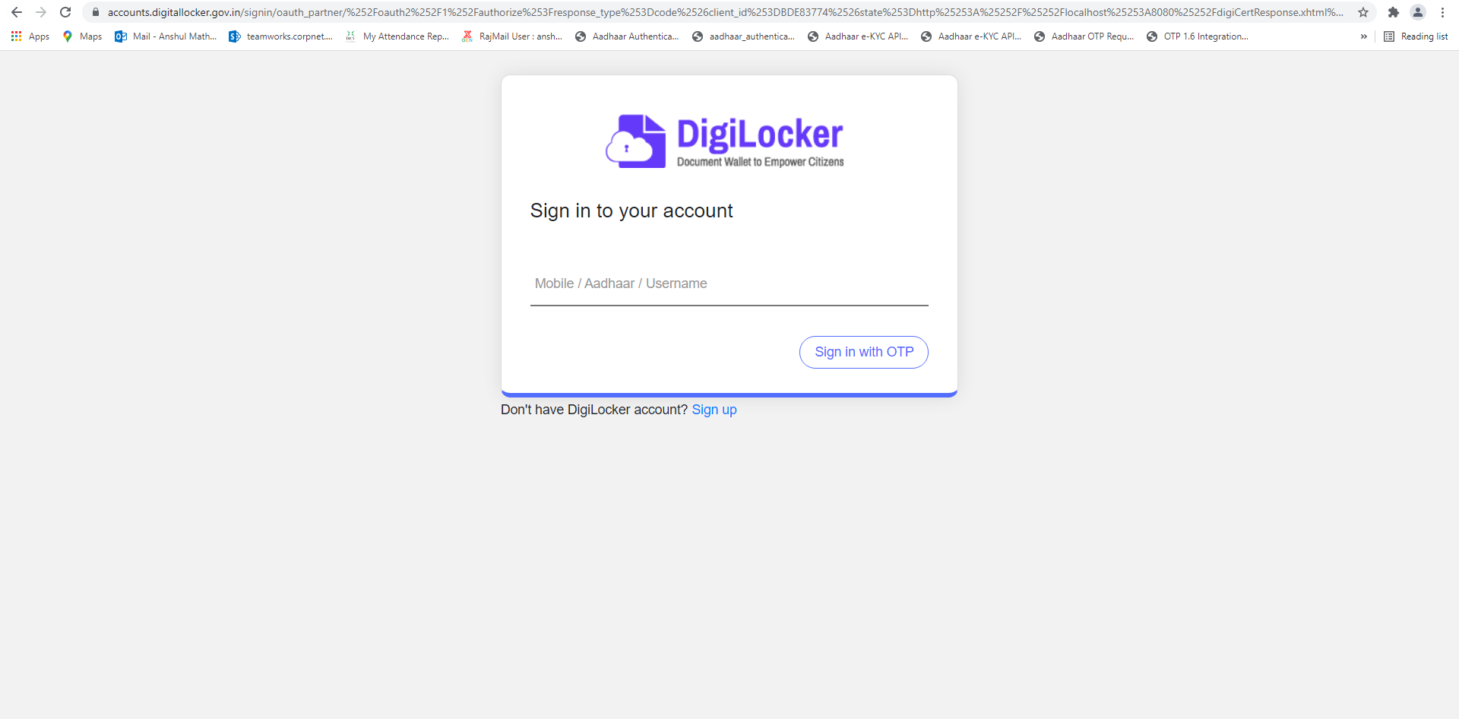

* The client will enter the mobile/Aadhaar/username and OTP (which will be received on the registered mobile number) and click on the “Continue” button.

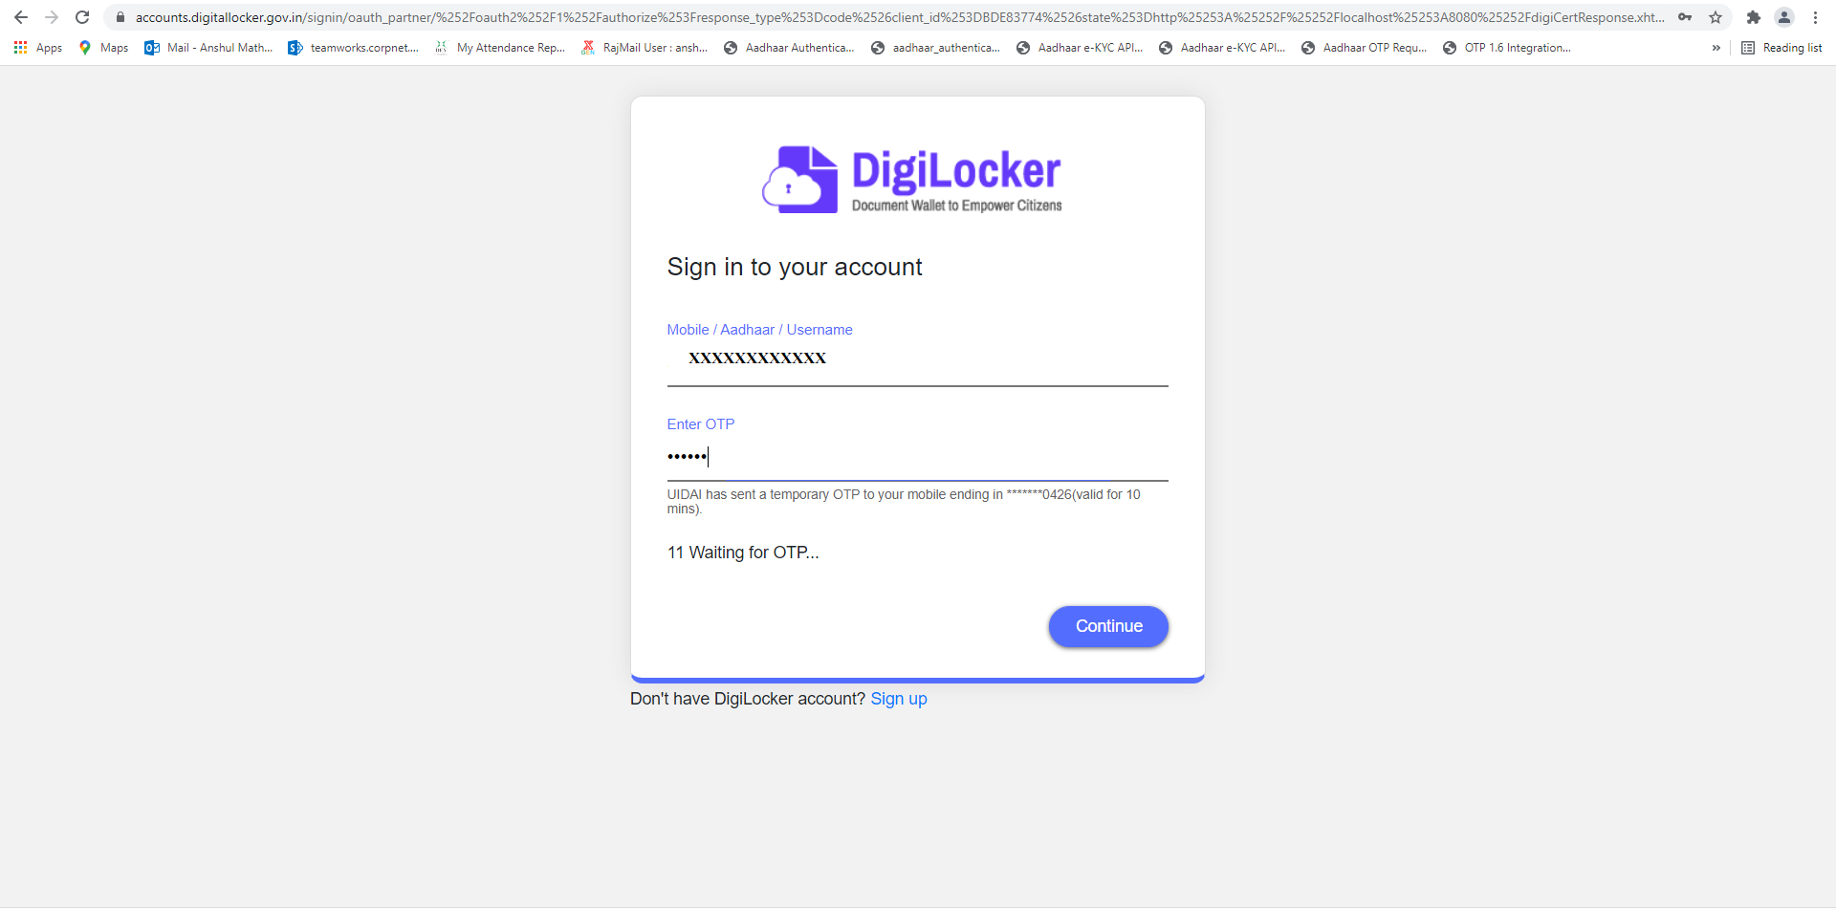

* The customer will enter the security pin to Sign in and click on Submit button.

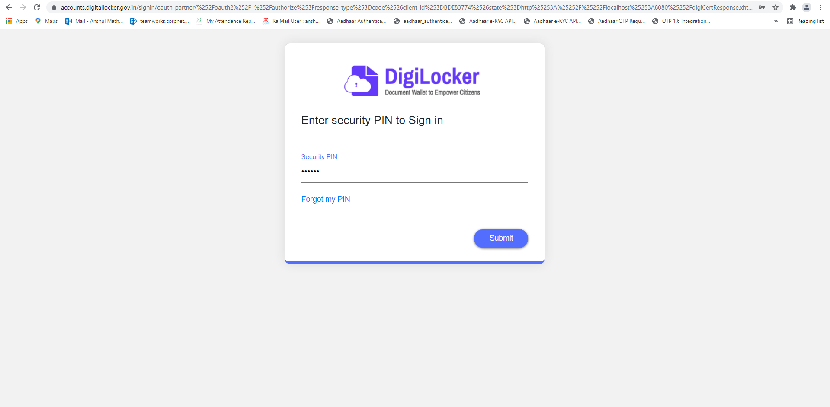

* After the successful sign-in, the client will click on “Allow” for access to the Digi locker and be redirected to the Return URL.

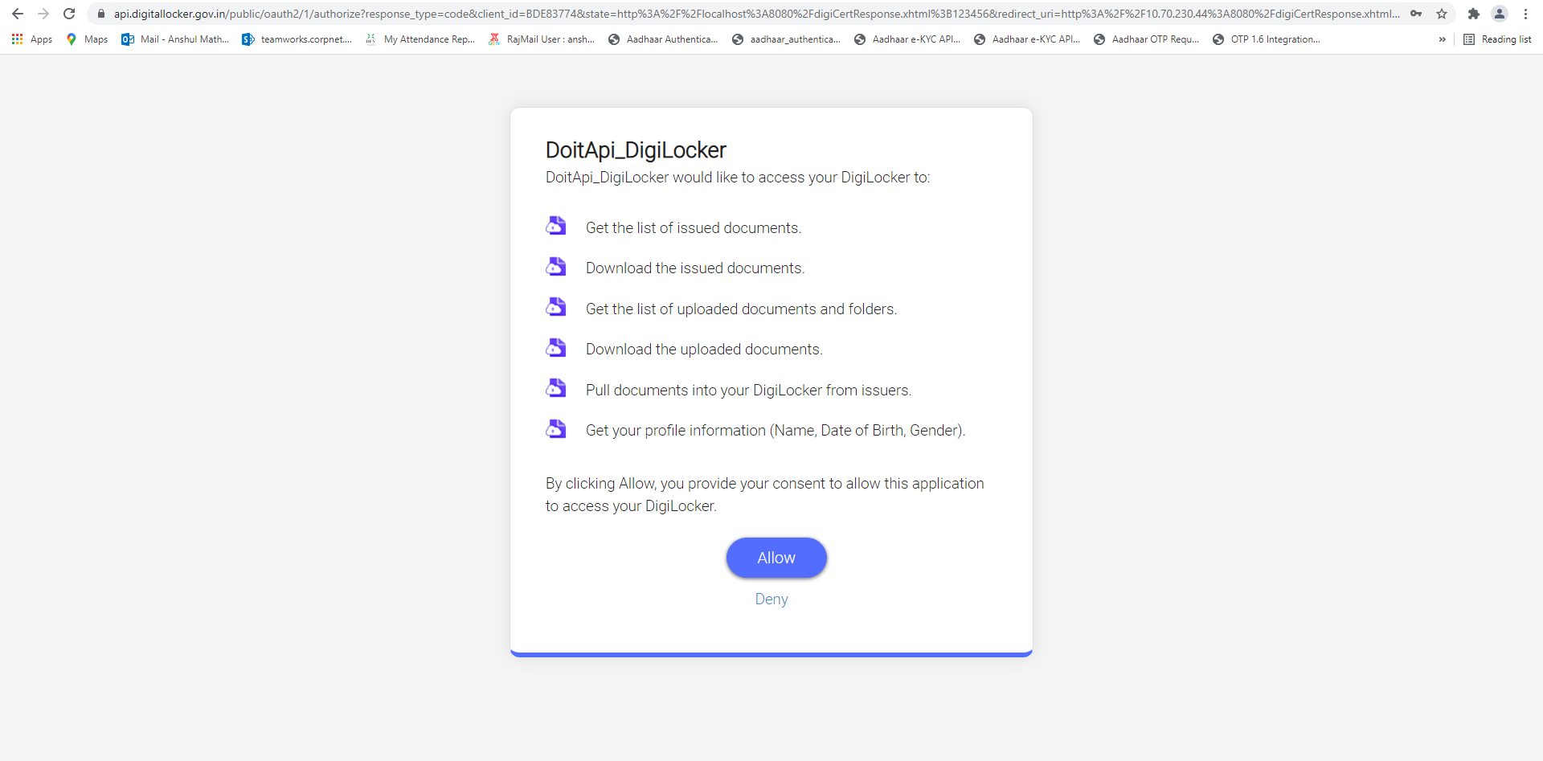

The End